Sukh Atwal, Yoshi Ryuzaki

CBC & CTR FEISTEL CIPHER

Table of Contents

Introduction 2

User Guide 3

Encryption 3

Decryption 5

Analysis 7

ECB (Electronic Codebook) 7

Diffusion 7

Confusion 7

Avalanche Effect 8

CBC (Cipher Block Chaining) 10

Diffusion 10

Confusion 10

Avalanche Effect 11

CTR (Counter) 13

Diffusion 13

Confusion 13

Avalanche Effect 14

Design 16

Application Flow 16

Encryption Modes 17

ECB 17

CBC 18

CTR 19

Subkeys Generation 20

Feistel Encryption Flow 21

Testing 23

Test 1 24

Test 2 26

Test 3 28

Test 4 30

Test 5 32

Test 6 34

Test 7 36

Test 8 38

Test 9 40

# Introduction

The Feistel cipher isn’t so much a cipher in itself, it’s more so of a framework for building encryption algorithm. It’s widely used in modern ciphers and has various different modes that affects both the confusion and diffusion properties.

Building off of the previous Assignment #5, we are going to add onto ECB mode with CBC and CTR. In addition to that, we are also going to implement a basic permutation scheme to generate subkeys from the main key that we input.

# User Guide

Here is the user guide of the application. Note that the functionality was verified and tested using Python 3.8 under a Windows environment. An README.md file will also be included with the same instructions located in the same folder.

When you first open the ‘Source’ folder, there should be 5 python script files and a few sample text/image files.

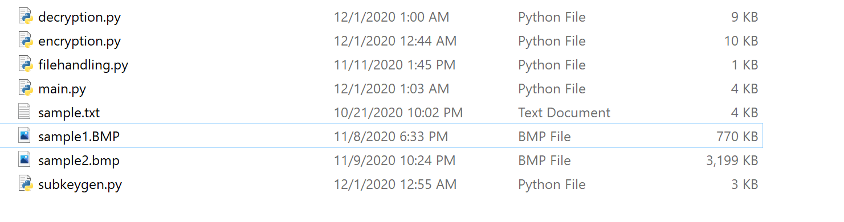

## Encryption

Here is the step-by-step guide for the encryption process:

1. First, we will launch the application using ‘python main.py’ or ‘python3 main.py’ command:



1. Next, after getting prompt, we will have to enter the operation mode we want to use (either encryption or decryption):

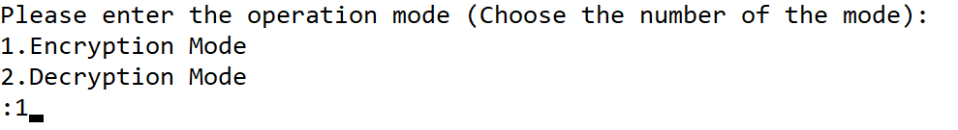

1. For now, we will use operation mode 1 which is the encryption mode. And the application will prompt us to choose the file type.

We will select 1 (Image File type) here:

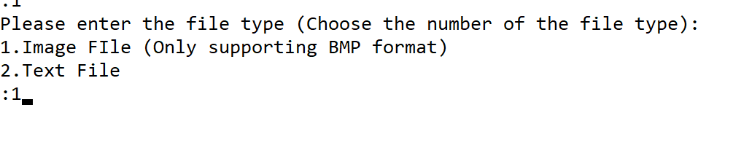

1. After selecting using what type of file, the application will prompt us for input file name. And we will use sample1.bmp for this case:

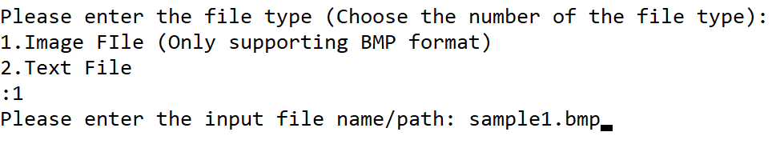

1. Next, we will also have to enter the output file name where we want to keep the encrypted data:



1. And now, we will create and enter a key phrase which we want to use to encrypt the file. The key phrase can be either alphabets or numbers. And the application only accepts the password which is longer than 3 characters. (The application also returns all the subkeys which will be generated based on the user entered key phrase)

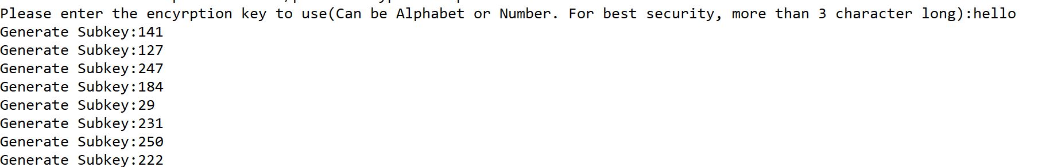

1. The application also prompts us to choose the encryption mode.

(This time we will choose CBC. When choosing CTR, user will also have to enter the initial counter value)

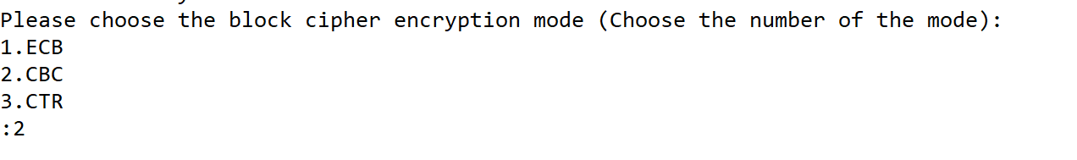

1. Then the application returns ‘Encrypting, please wait’, and we will wait till the application prints ‘Finished Encryption’ message.

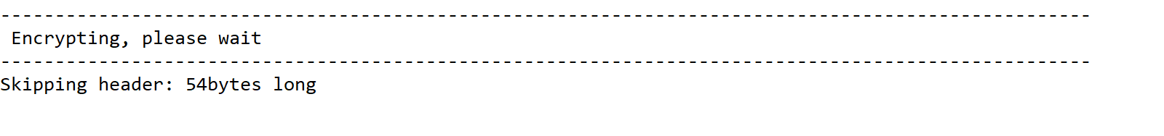

1. Finally, the encryption process is over, you should find a file called encrypted1.bmp.





## Decryption

The decryption process is very similar to the encryption process.

Here is the step-to-step guide of the decryption process:

1. First, we will use ‘python main.py’ or ‘python3 main.py’ to launch the application:



1. Next, we will be choosing the operation mode. Since we want to decrypt the file this time, we will be choosing 2:

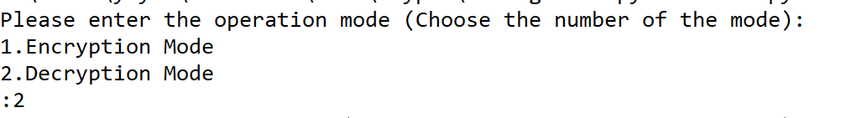

1. The application then prompts us to enter the file type, we will pick 1 this time:

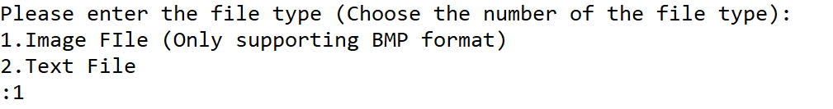

1. And we also have to pass the input and output fie names/paths to the application when getting prompted:



1. Next, we will enter the key phrase we used for encryption:

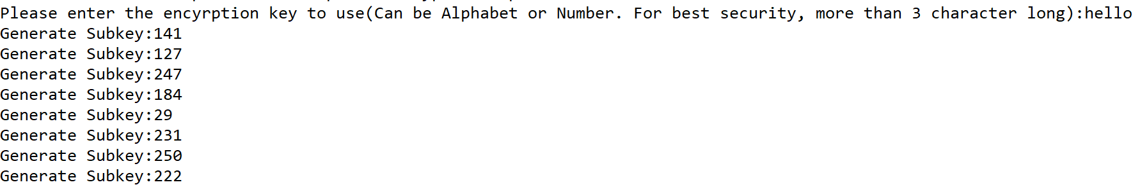

1. And at last, we will choose the encryption mode we used for encrypting the file, and just wait for the decryption process to be finished:

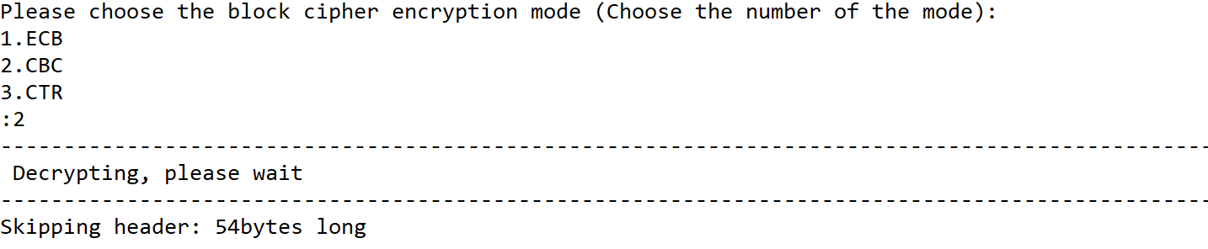

1. Once the application returns ‘Finished decryption’ message, then we can check the folder and find the decrypted1.bmp file.



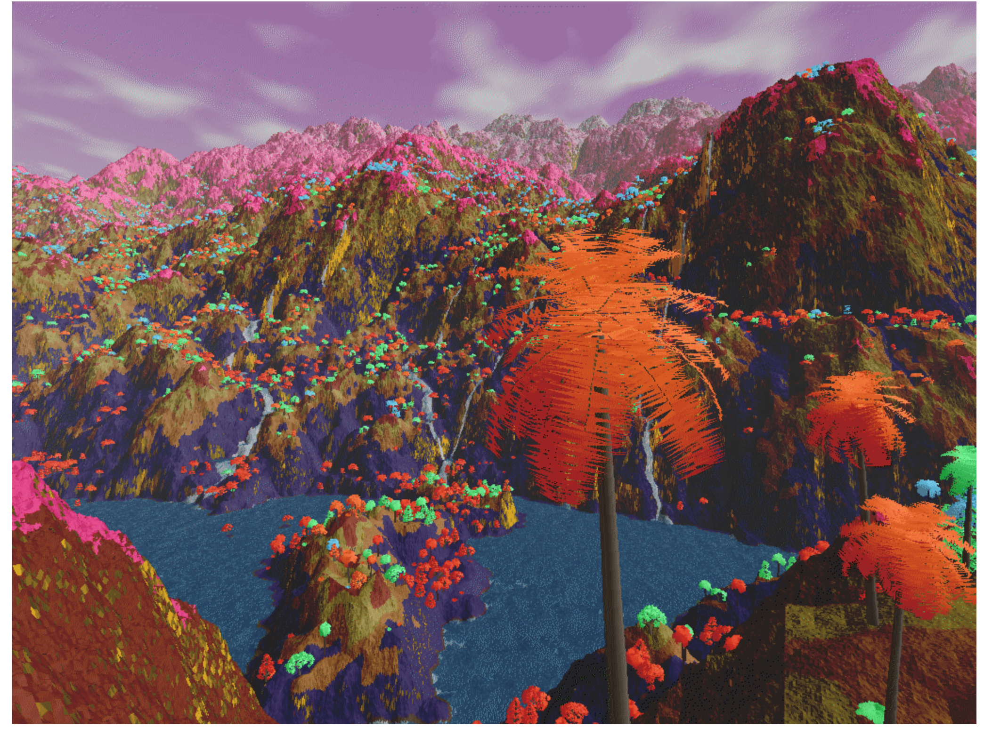

# Analysis

## ECB (Electronic Codebook)

ECB otherwise known as Electronic Codebook is one of the easier modes, where the plaintext is divided into pre-determined block sizes and then performs encryptions on them using the provided key. To decrypt, it’s the same process.

### Diffusion

One of the biggest issues with ECB is diffusion, more specifically the lack of it. Take a look at the following two images using the key ‘bcit’.

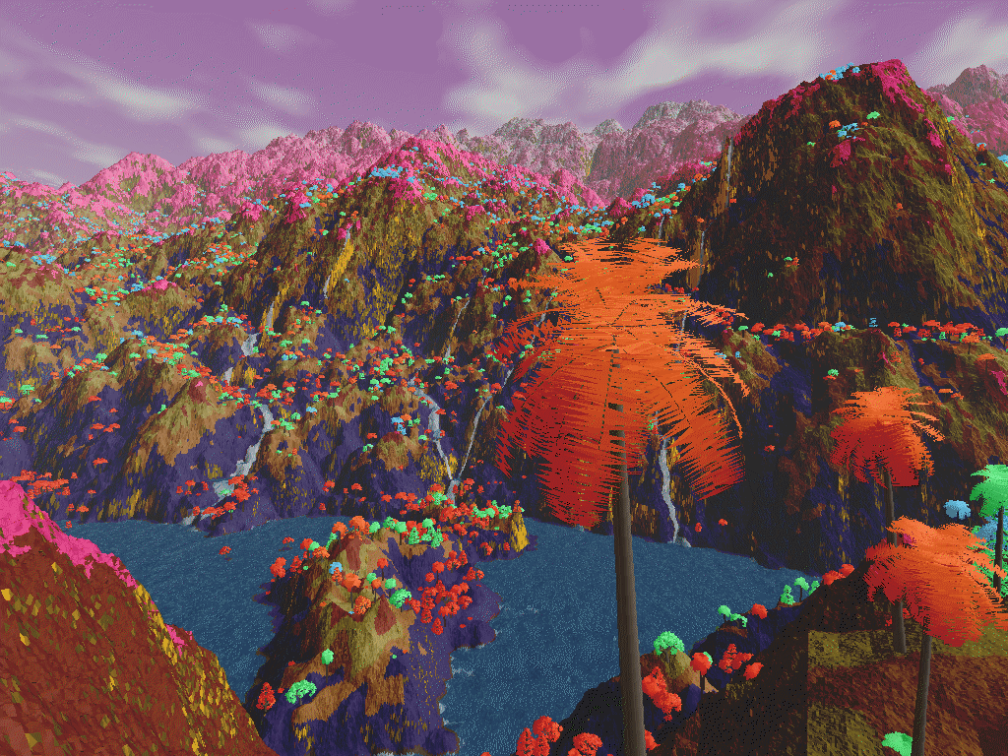 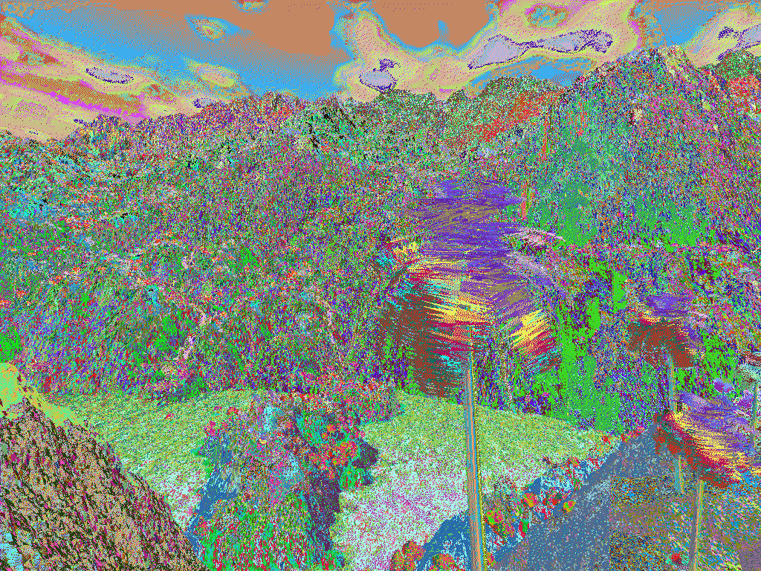

The image on the right is the original image and the one on the left is after encrypting it. We can see parts of the image match with one another, showing that ECB doesn’t hide the pattern of the data very well.

Each individual pixel might be encrypted but the overall image can still be perceived since the pattern of colors in the original still remain in the encrypted. We can still see the general colors from the image on the left in the image on the right. This is more of a problem with the way the encryption mode, and there are better modes to use such as CBC or CTR which we’ll look at.

### Confusion

When looking at the confusion side, I’m looking at the relationship between the ciphertext and key and whether it’s possible to get the key from the ciphertext.

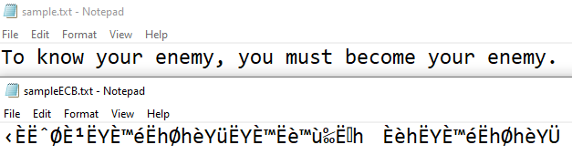

Here I used the same key as the image ‘bcit’, and it produces essentially random text, there’s no way to get the key. An issue however is that if two messages and the key are the same, the ciphertext would output the same both times. However, there’s no way you can work back the key or encryption algorithm from just the ciphertext alone. Therefore, I would say that this algorithm has moderate confusion. Moderate because while implementing using a Feistel structure does improve the confusion, ECB is a bottleneck in terms of how much you can do with it. To improve the confusion, we could increase the block size or use other block mode ciphers as mentioned before such as CBC.

### Avalanche Effect

The following is a table of bits changed in the plaintext as well as changes in the key for SPAC.

|  |  |  |
| --- | --- | --- |
| **Round** | **Bits Changed in Cipher** | **Percentage Changed** |
| 1 | 3 | 0.40% |
| 2 | 6 | 0.80% |
| 3 | 204 | 27.35% |
| 4 | 20 | 2.65% |
| 5 | 232 | 31.10% |
| 6 | 32 | 4.24% |
| 7 | 37 | 4.96% |
| 8 | 42 | 5.63% |
| 9 | 269 | 36.45% |
| 10 | 272 | 36.86% |
| 11 | 117 | 15.66% |
| 12 | 264 | 35.77% |
| 13 | 290 | 39.78% |
| 14 | 276 | 37.40% |
| 15 | 215 | 28.78% |
| 16 | 202 | 26.72% |
| 17 | 163 | 21.82% |
| 18 | 165 | 22.09% |
| 19 | 162 | 21.69% |
| 20 | 161 | 21.55% |

As well as for SKAC.

|  |  |  |
| --- | --- | --- |
| **Key** | **Bits Changed in Cipher** | **Percentage Changed** |
| 1 | 528 | 55.87% |
| 2 | 471 | 53.40% |
| 3 | 628 | 60.15% |
| 4 | 377 | 46.54% |
| 5 | 519 | 55.45% |
| 6 | 346 | 54.15% |
| 7 | 310 | 42.01% |
| 8 | 431 | 51.49% |
| 9 | 524 | 54.41% |
| 10 | 487 | 53.58% |

To get a clearer understanding, I’ve converted them to line graphs.

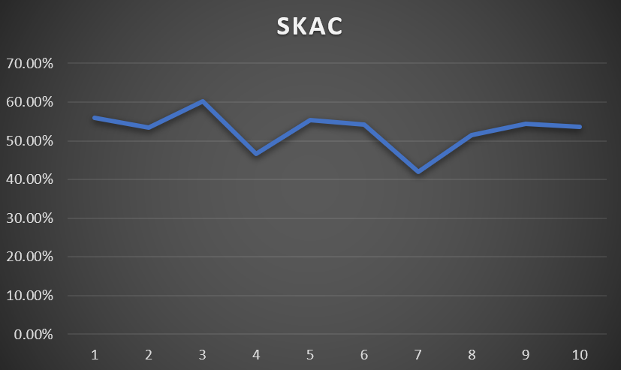

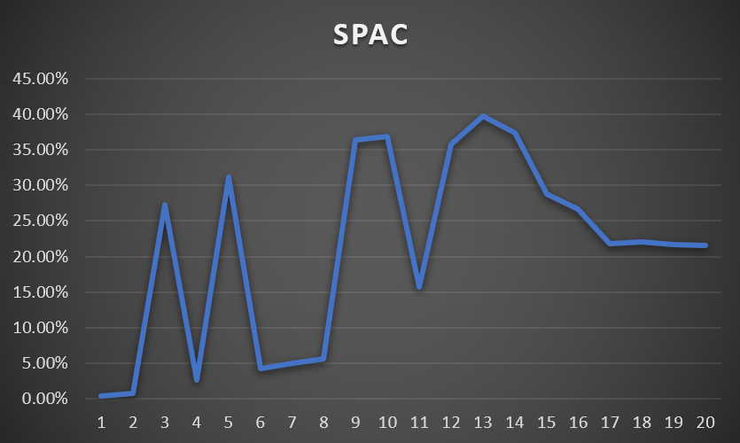

SKAC data was collected using the same plaintext but different keys (From 1-10). Meanwhile, SPAC data is from modifying plaintexts one at a time. It’s hard to say whether the change percentage would remain stagnant if we went beyond round 20 for SPAC however it’s still on the lower side. Compared to SKAC, which is consistently hitting 50% and only dropped to 40% in the number of bits changed once. I would say this is a somewhat desirable area to hit however there are still rooms for improvement.

## CBC (Cipher Block Chaining)

CBC otherwise known as Cipher Block Chaining is, in a sense, an extension of ECB mode. The plaintext is divided into blocks and then encrypted with the key. Before the encryption is actually performed, the plaintext block is XOR’d with the ciphertext of the previous block which ends up increasing the confusion and diffusion properties, a weakness of ECB that was pointed out previously. To decrypt, the process is reversed.

### Diffusion

Here we can see two images side by side using CBC and the key ‘bcit’.

 

Unlike the previous image we looked at that was encrypted using ECB, it’s extremely hard to find any patterns in the CBC encrypted image. Through the usage of ‘pseudo random’ IV, the confusion has been greatly improved upon. A weakness of CBC however is that the encryption itself is sequential however for the purposes of this, CBC has strong diffusion.

### Confusion

Similar to ECB, when looking at the confusion side I’m looking at the relationship between the ciphertext and key and whether it’s possible to get the key from the ciphertext.

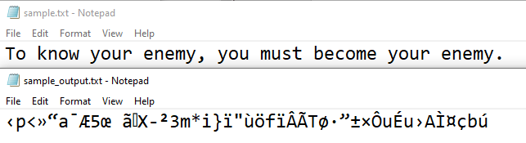

Here we can see that it’s impossible to see any relation between the ciphertext and the key which again was ‘bcit’. There’s no reasonable way to know what the ciphertext or key could be from observing the output. An issue I noticed when looking at the confusion was that the length of the sample text was the same as the length of the encrypted text, which can be an issue. Here is another example of what I mean.

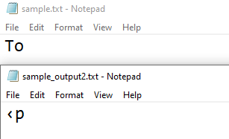

With a smaller text needing to be encrypted the output would be the same length.

### Avalanche Effect

The following is a table of bits changed in the plaintext as well as changes in the key for SPAC.

|  |  |  |
| --- | --- | --- |
| **Round** | **Bits Changed in Cipher** | **Change Percentage** |
| 1 | 14 | 1.97% |
| 2 | 48 | 6.84% |
| 3 | 81 | 11.54% |
| 4 | 135 | 20.27% |
| 5 | 153 | 22.97% |
| 6 | 139 | 20.59% |
| 7 | 176 | 26.43% |
| 8 | 253 | 37.48% |
| 9 | 359 | 56.18% |
| 10 | 303 | 45.50% |
| 11 | 374 | 59.37% |
| 12 | 351 | 57.35% |
| 13 | 304 | 42.76% |
| 14 | 346 | 45.77% |
| 15 | 320 | 45.58% |
| 16 | 327 | 48.44% |
| 17 | 334 | 50.84% |
| 18 | 293 | 40.69% |
| 19 | 339 | 51.60% |

As well as for SKAC.

|  |  |  |
| --- | --- | --- |
| **Key** | **Bits Changed in Cipher** | **Change Percentage** |
| duckduckgo | 317 | 48.25% |
| duckduckgg | 315 | 45.45% |
| duckdukkgg | 315 | 50.72% |
| dvckdukkgg | 315 | 50.72% |
| dvckdukpgg | 297 | 47.83% |
| zuckdukpgg | 297 | 44.59% |
| zvckdukpgg | 313 | 44.02% |

Converting both to line graphs produces the following:

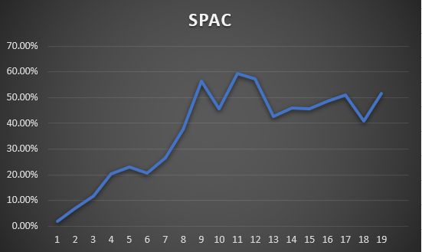

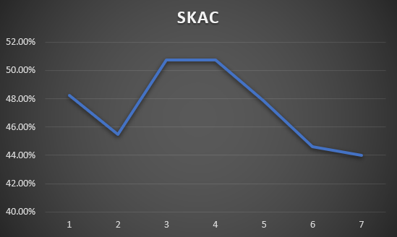

SKAC data was collected using the same plaintext but with a key with single bits changing throughout each interaction. Meanwhile, SPAC data is from modifying the plaintext one bit at a time using the same key throughout. Both graphs remains consistently between 40% to 60% outside of the initial bit changes for SPAC.

## CTR (Counter)

CTR otherwise known as Counter mode essentially ensures that a sequence will not repeat for a very long time. The plaintext is substituted with different values every time, thus having a very good confusion property. Unlike the previous two modes covered, EBC and CBC, the encryption is done with a counter, key and nonce which is then XOR’d to produce the ciphertext.

### Diffusion

Here we can see two images side by side using CTR and the key ‘bcit’ and a counter number of 47.

 

From the image above, we can see that while it’s better than when we encrypted the image using ECB, it’s not as good as when we used CBC previously. This could be due to sacrificing speed for performance as running CTR has been faster than CBC due the encryption being parallelized (You’re don’t need to rely on other blocks so the encryption can be done in parallel).

### Confusion

Similar to the methods above I’ll be again looking at the relation between the key and ciphertext.

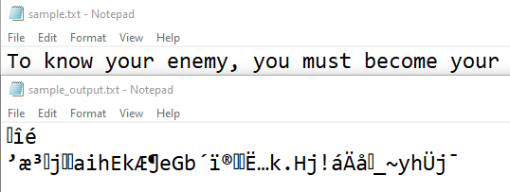

We can see that there’s no discernable way to get the key from the given ciphertext. In addition to having a secret key, CTR also has a nonce which is shared between the sender and receiver. While the ciphertext is the same length as the plaintext similar to the methods above, the relation between having to use both a key and nonce adds to the confusion factor.

### Avalanche Effect

The following is a table of changes in bits for the plaintext (SPAC). I used the same counter value of 24.

|  |  |  |
| --- | --- | --- |
| **Round** | **Bits Changed in Cipher** | **Change Percentage** |
| 1 | 23 | 3.60% |
| 2 | 29 | 4.48% |
| 3 | 217 | 33.03% |
| 4 | 222 | 33.33% |
| 5 | 224 | 33.63% |
| 6 | 280 | 42.04% |
| 7 | 244 | 36.15% |
| 8 | 232 | 34.83% |
| 9 | 242 | 35.85% |
| 10 | 241 | 36.19% |
| 11 | 246 | 36.94% |
| 12 | 198 | 29.33% |
| 13 | 168 | 25.23% |
| 14 | 187 | 28.08% |
| 15 | 143 | 22.07% |
| 16 | 283 | 43.07% |
| 17 | 283 | 41.93% |
| 18 | 276 | 40.89% |
| 19 | 275 | 41.29% |

As well as for changes in the bits for the key.

|  |  |  |
| --- | --- | --- |
| **Key** | **Bits Changed in Cipher** | **Change Percentage** |
| duckduckgo | 317 | 48.25% |
| duckduckgg | 315 | 45.45% |
| duckdukkgg | 315 | 50.72% |
| dvckdukkgg | 315 | 50.72% |
| dvckdukpgg | 297 | 47.83% |
| zuckdukpgg | 297 | 44.59% |
| zvckdukpgg | 313 | 44.02% |

For better visualization, here’s line graphs for each one.

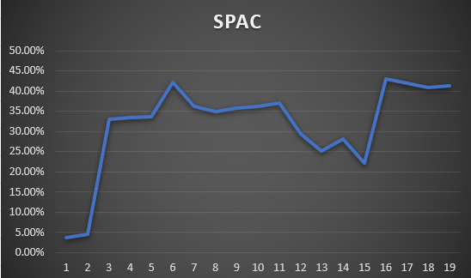

From the SPAC graph, we can see that the percentage in change is a fair bit lower from the initial data of up to 19-bit changes, but it starts to normalize at around 40%. On the other side, we can see the SKAC stay consistently between the 38% to 56% mark.

# Design

## Application Flow

As always, first let us look at the high-level application flow:

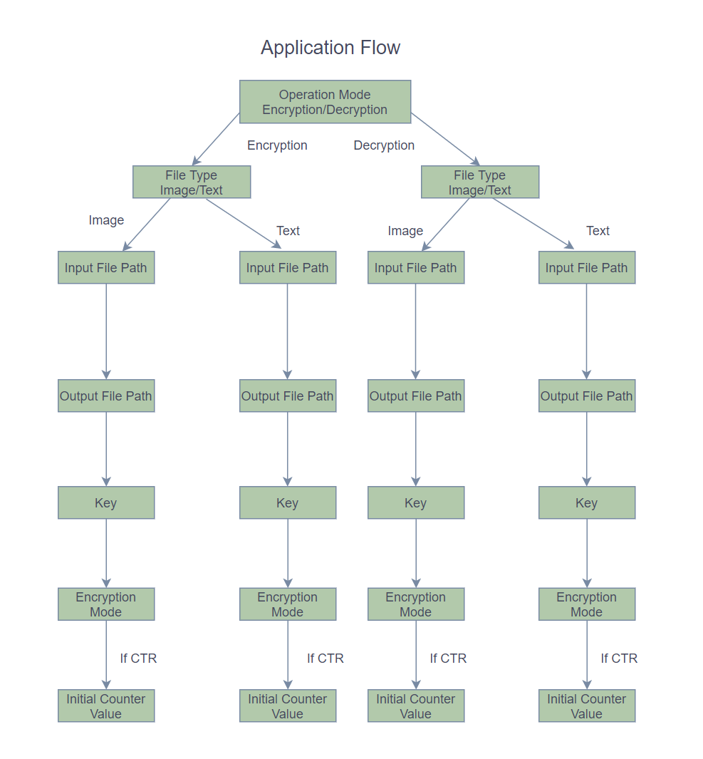

The application first prompts users for the operation mode, which can be encryption or decryption. And once user has picked the operation mode, then it asks for the file type of the input file; the reason of it is that the application performs different encryption and decryption processes based on the type of the file in order to avoid manipulating the original file header.

After confirming the file type, the application will then prompt user for entering the input and output file paths. The user will have to choose one of the following three encryption modes (Detailed design of each encryption mode will be explained in the next section):

1. ECB mode
2. CBC mode
3. CTR mode (User also needs to enter initial counter value)

Once the encryption mode is chosen, the application then encrypts or decrypts the inputted file using the chosen encryption mode and saves the encrypted or decrypted data as the output file.

## Encryption Modes

### ECB

Let us take a look at the ECB mode encryption design:

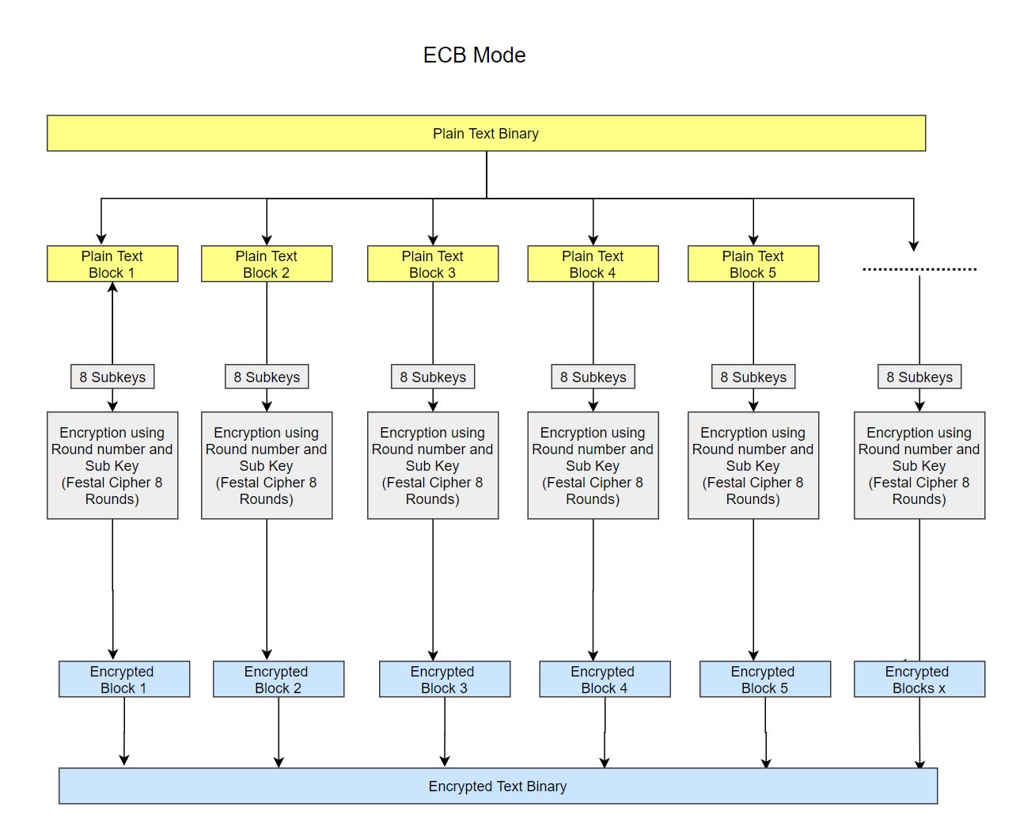

ECB is the most basic block cipher encryption mode. When using ECB encryption mode, the application will simply divide the original plain text binary into small binary blocks, and each binary block will get encrypted using the same encryption process. At the end, these small encrypted binary blocks will be put back together to form the encrypted cipher message or image.

Problem with this encryption mode is that each of the binary blocks will go through the exact same encryption process, thus the confusion and diffusion of the encryption is hugely impacted by the block size of the binary blocks.

### CBC

Next, we’ll look at the CBC mode encryption design:

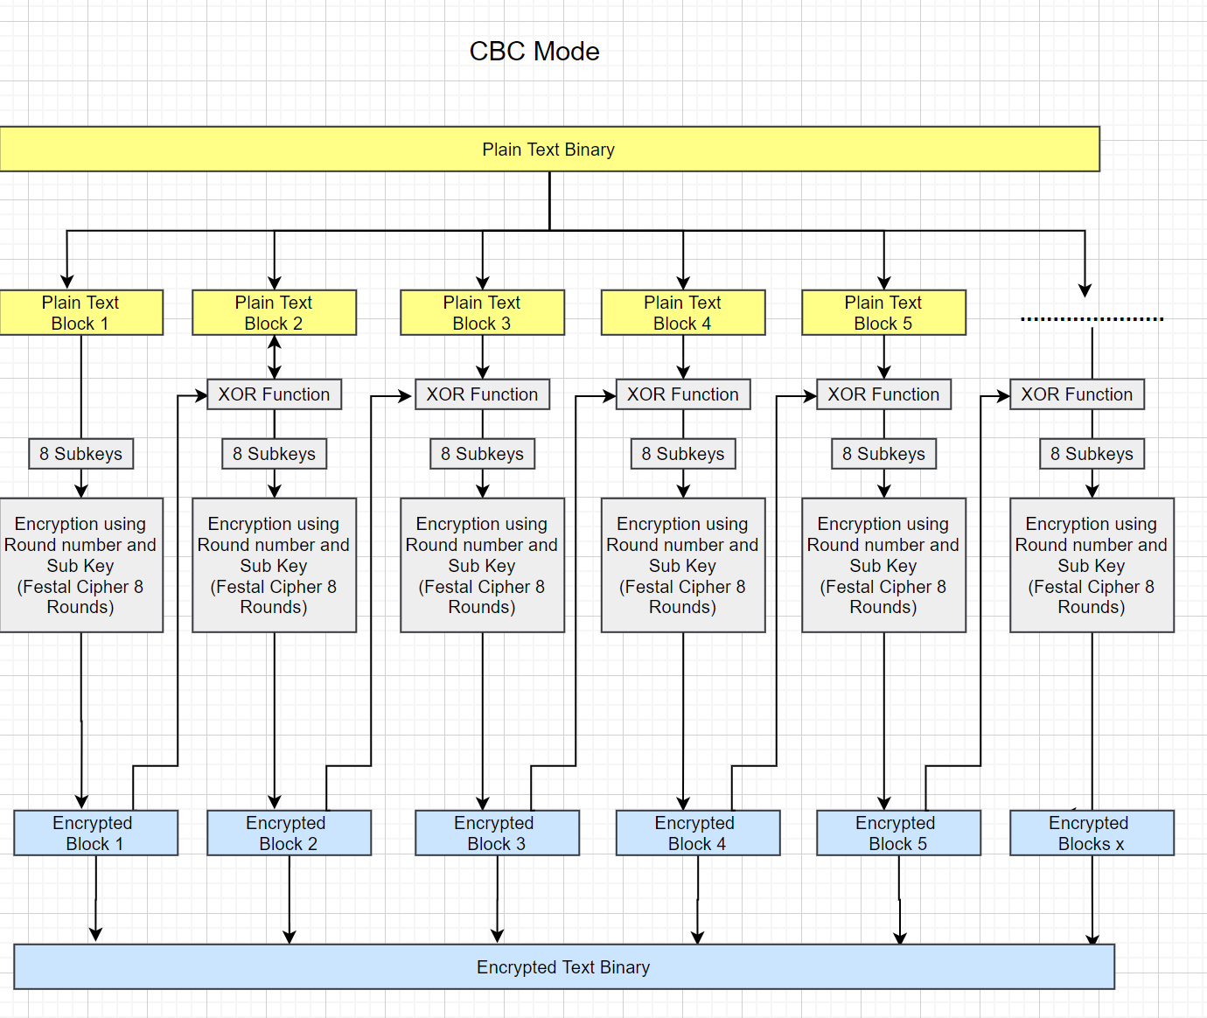

CBC mode stands for Cipher Block Chaining mode. From its name, we probably can tell it functions by chaining all binary blocks together.

CBC mode works very similar to the ECB mode, the only major difference is before each plaintext binary block gets encrypted, it will first get an XOR comparison against the encrypted binaries of the previous block. As the result, each binary block will be one of the encryption parameters of the next binary block, so almost all binary blocks will get encrypted uniquely. And therefor, the CBC mode will have a much better confusion than the ECB mode.

### CTR

Here is the design for CTR mode:

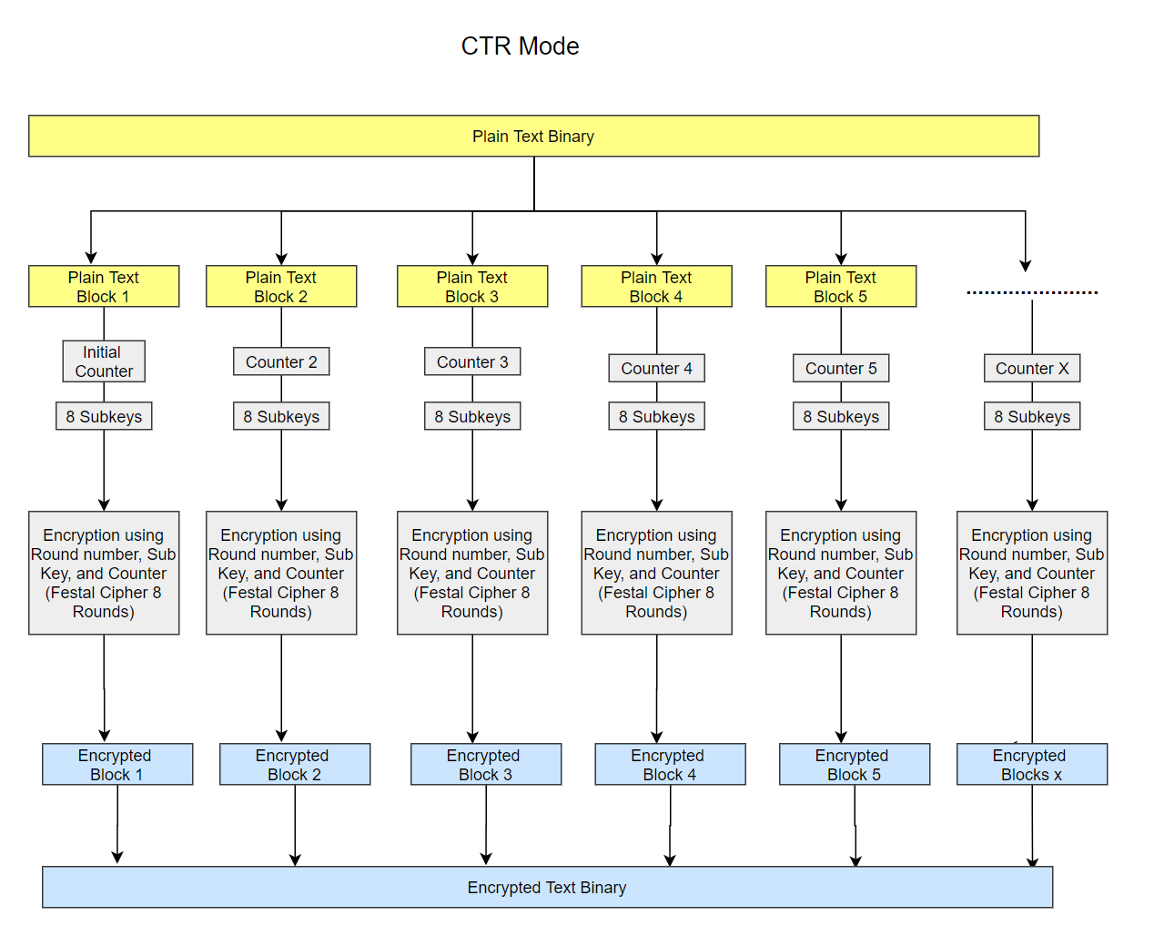

CTR mode stands for Counter mode. It is also very similar to the ECB mode. The major difference between the CTR mode and the ECB mode is that instead of only using the subkeys or subkeys and round numbers to encrypt each binary block, the CTR mode also uses the counters as an extra encryption input. Usually, user will have to pick an initial counter value, and the system will modify the counter value for each different binary blocks. Therefore, the confusion and diffusion will get hugely improved when comparing to the ECB mode.

## Subkeys Generation

All of the encryption modes above uses subkeys as one of the encryption inputs. Here is the design: 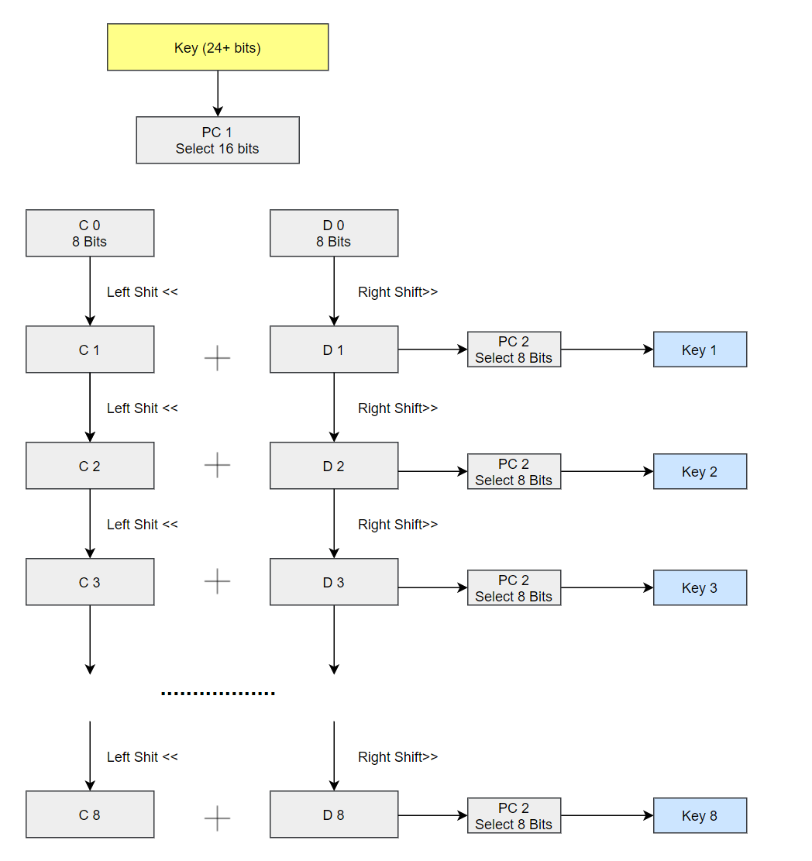

As we can see in the above graph, a key which is 24 bits or longer will be passed to the sub key generation function. (Only for this application, standard DES often uses 64 bits long key)

And the function will first pick 16 bits from these 24 bits based on the filter called PC1 (Permuted Choice 1, which defines which bits will get processed).

Next, the function divides the 24 bits into C and D sections, each section will have 8 bits.

Now to generate a new subkey, the function will left shift the binary inside the C section (So 00010000 will become 00100000) and right shift the binary inside the D section (So 00010000 will become 00001000). Then it concatenates the C and D sections and uses PC2 (Permuted Choice 2) to further filter the binary down to 8 bits. The 8 bits long binary is the final subkey.

And to generate 8 subkeys, the function will repeat the same processes 8 times.

## Feistel Encryption Flow

Next, let’s look at the Feistel encryption flow design:

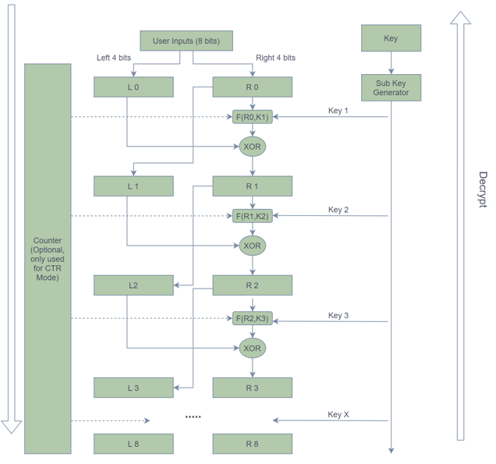

It has a scrambling function of:

$$f\text{i}\left(x,k\right)=\left[{\left(2i*k+c\right)}^{x}\right] mod 15$$

Where i is the number of the round; and K is the encryption Key (Any integer).

Where c is the counter, which will only be a non-zero number when using CTR mode.

Like any other Feistel encryption algorithms, the application first splits the plain text binary block into two parts the left part - L and the right part – R. Next, the application will add the value in a current round of R to the next round of L. It will also pass the value into the current round of R to the scrambling function. The scrambling function encrypts it based on the number of the current round, generated sub key and the counter number (if applicable, only for CTR mode). The application then uses the result from the scrambling function to perform a XOR comparison against the value in the current round of L. The output of the XOR comparison will then be added to the next round of R.

To summarize the Feistel encryption process of each round, we can use the following two equations:

$$L_{i}=R_{i-1}$$

$$R_{i}= L_{i}⨁F(R_{i-1},K_{i})$$

Currently, the application is configured to perform 8 rounds of the Feistel encryption process, but which can be changed anytime.

The decryption process is also very straightforward, the application will simply reverse the above Feistel encryption processes to decrypt the encrypted files.

# Testing

My setup for testing is a Windows 10 computer, where I’ll be IDLE to run the script.

Note that for Test 1 and Test 2, the videos in the ‘Videos’ folder are significantly longer due to problems with deleting the waiting portion of the encryption and decryption of images. The issue was resolved for Test 3 and onwards.

|  |  |  |  |  |
| --- | --- | --- | --- | --- |
| **Test #** | **Tools Used** | **Expectation** | **Actuality** | **Result** |
| 1 | IDLE | I should be able to encrypt the Plaintext and Image file using a key that I can choose with ECB | I was able to encrypt the files using a key I chose | PASS |
| 2 | IDLE | I should be able to decrypt the encrypted Plaintext and Image from Test #1 using the same key with ECB | I was able to decrypt the files from Test #1 using the same key | PASS |
| 3 | IDLE | I shouldn’t be able to decrypt the encrypted Plaintext and Image from Test #1 using a different key with ECB | I wasn’t able to decrypt the files from Test #1 using the key that wasn’t used for the encryption originally | PASS |
| 4 | IDLE | I should be able to encrypt the Plaintext and Image file using a key that I can choose with CBC | I was able to encrypt the files using a key I chose | PASS |
| 5 | IDLE | I should be able to decrypt the encrypted Plaintext and Image from Test #4 using the same key with CBC | I was able to decrypt the files from Test #4 using the same key | PASS |
| 6 | IDLE | I shouldn’t be able to decrypt the encrypted Plaintext and Image from Test #4 using a different key with CBC | I wasn’t able to decrypt the files from Test #4 using the key that wasn’t used for the encryption originally | PASS |
| 7 | IDLE | I should be able to encrypt the Plaintext and Image file using a key that I can choose with CTR | I was able to encrypt the files using a key I chose | PASS |
| 8 | IDLE | I should be able to decrypt the encrypted Plaintext and Image from Test #5 using the same key with CTR | I was able to decrypt the files from Test #5 using the same key | PASS |
| 9 | IDLE | I shouldn’t be able to decrypt the encrypted Plaintext and Image from Test #5 using a different key with CTR | I wasn’t able to decrypt the files from Test #5 using the key that wasn’t used for the encryption originally | PASS |

## Test 1

For this test, I should be able to encrypt a text and image file using a key that I can choose with ECB.

For all of the text portion, I’ll be using a text file called sample.txt with the following line in it, “To know your enemy, you must become your enemy” for all the tests moving forward.

When running the script from idle, I’ll be choosing “1” for encryption mode, “2” for text file, the key will be “canada2020” and the encryption mode will be “1” for ECB.

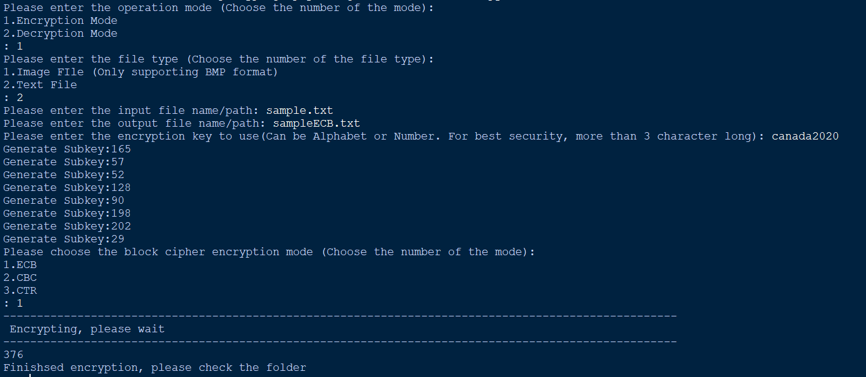

When I open the text files, you can see the text has been successfully encrypted. 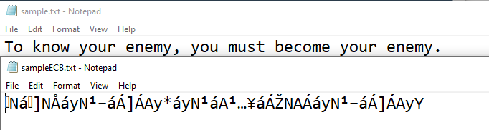

For the image encryption portion, I’ll be using the following two BMP images labeled sample1.BMP and sample2.bmp for this test and all the ones following it.



Similar to the text encryption above, the only difference is that I’ve chosen “1” for Image file.

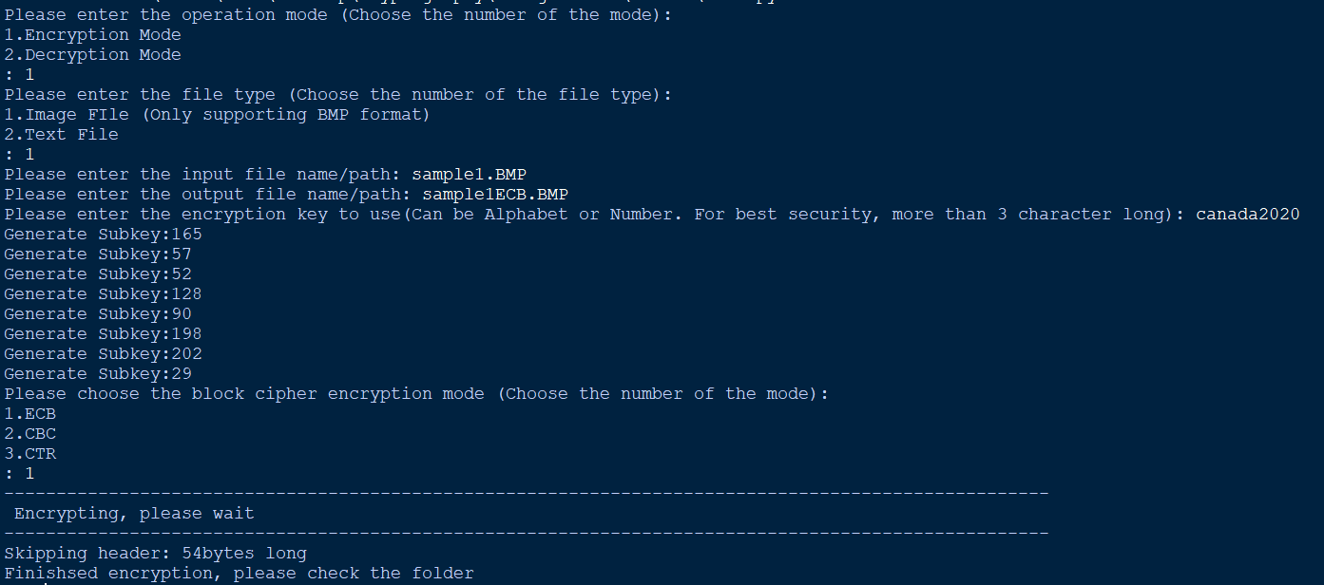

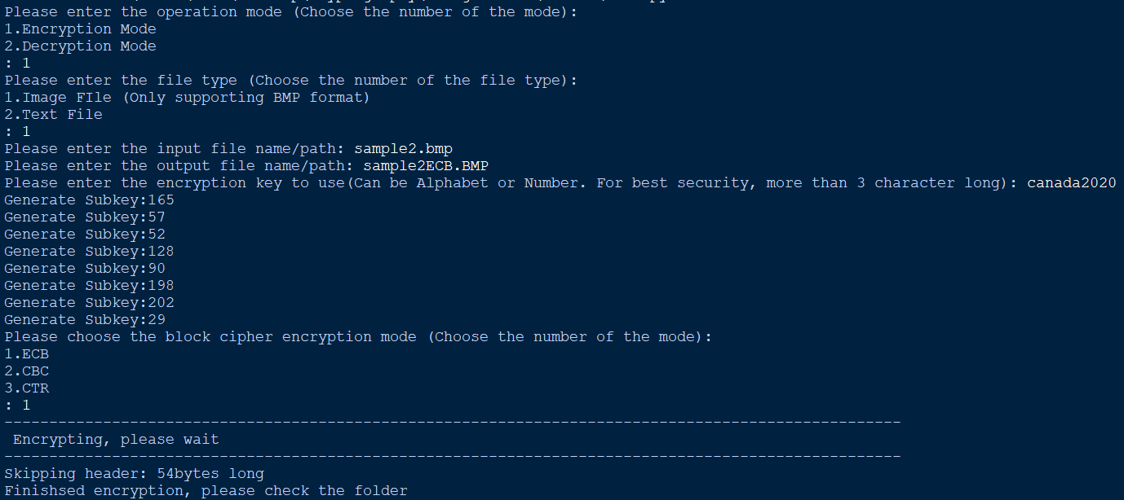

When I open the images, both look to be encrypted successfully.

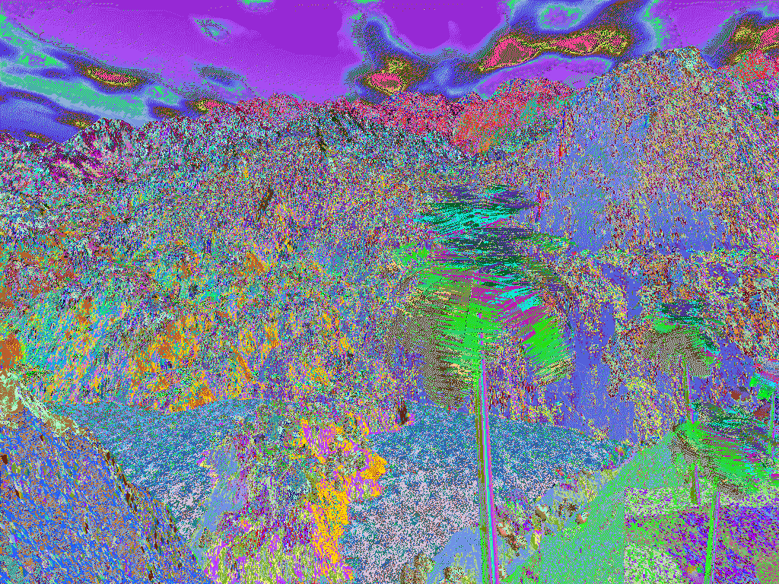

## Test 2

Here I’ll be testing the decryption function for the encrypted files from Test #1 using the same key as was used during the encryption.

The following were the steps taken to decrypt the text.

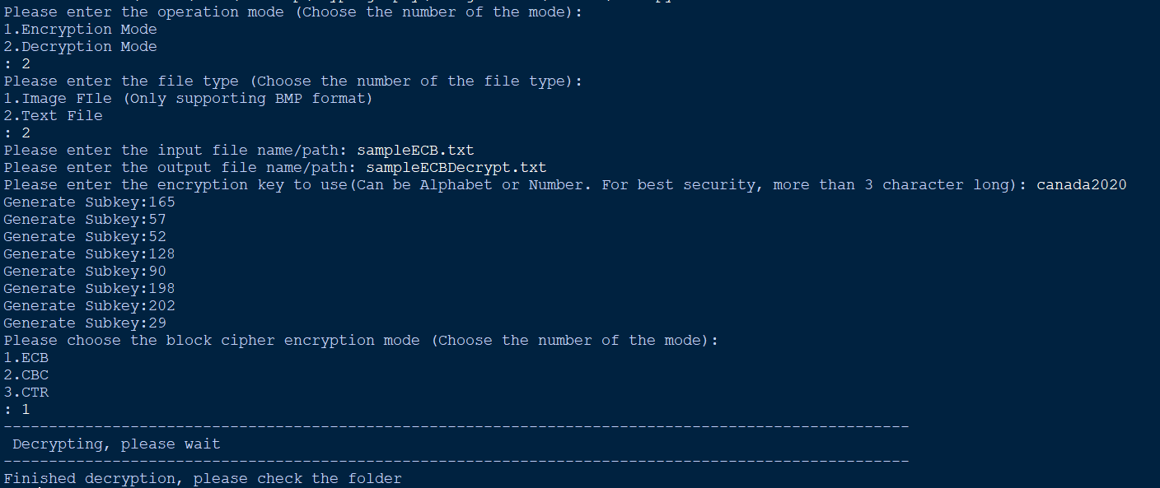

As shown below, the text file has been successfully decrypted to the original text file.

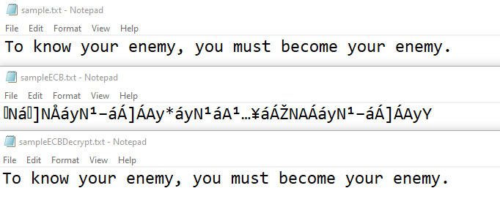

Now I’ll be doing the same process for the two images.

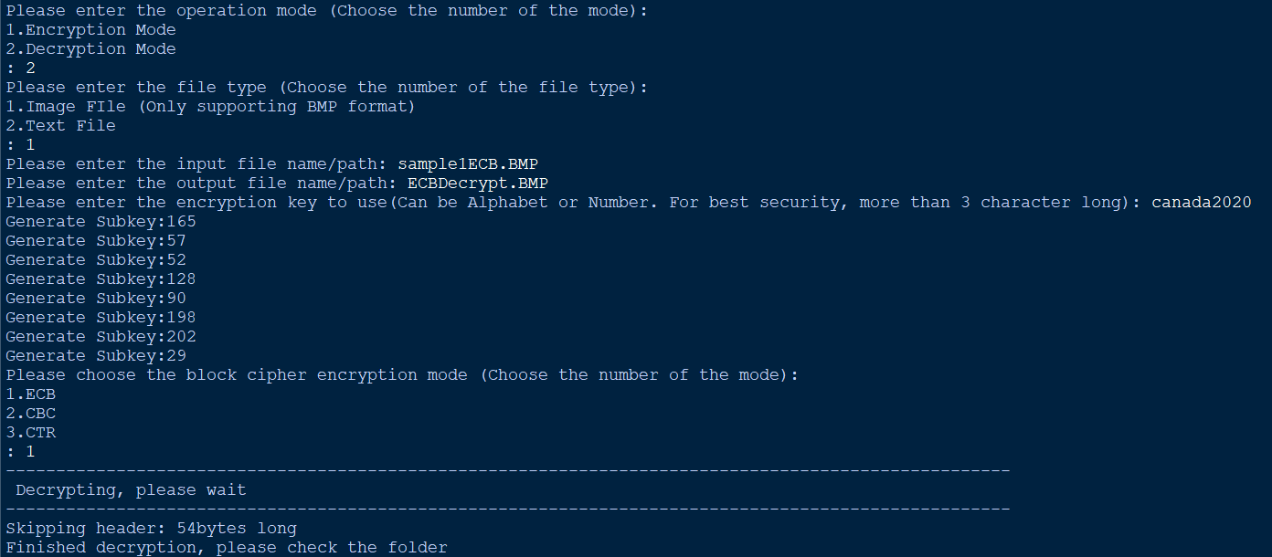

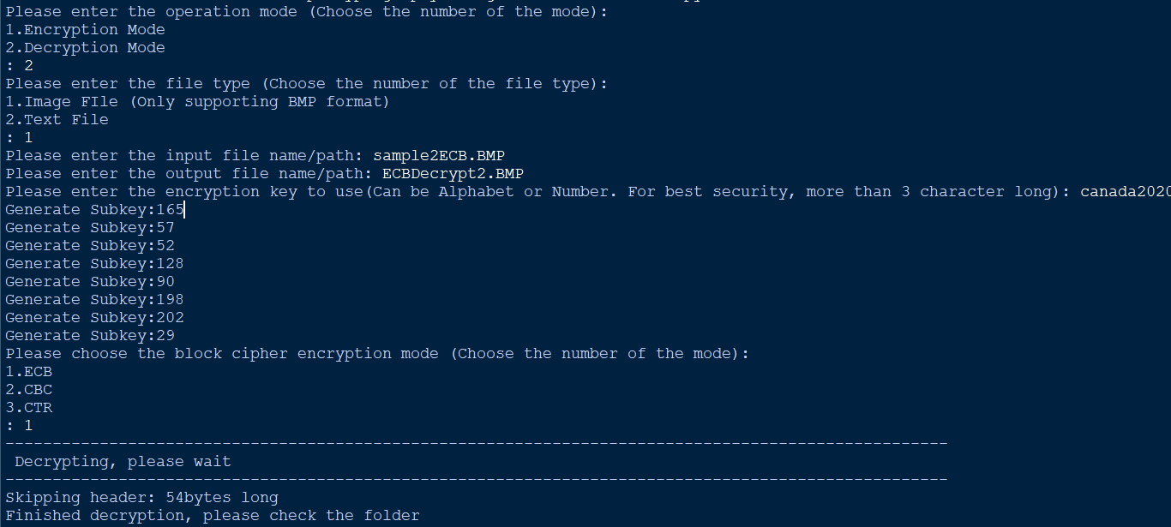

When we open the images, we get the following images successfully decrypted.



## Test 3

Here I’ll test if using a key that isn’t the same as the one I used to encrypt would decrypt the files.

I used ‘british123’ as the key which is different from the original key, ‘canada2020’.

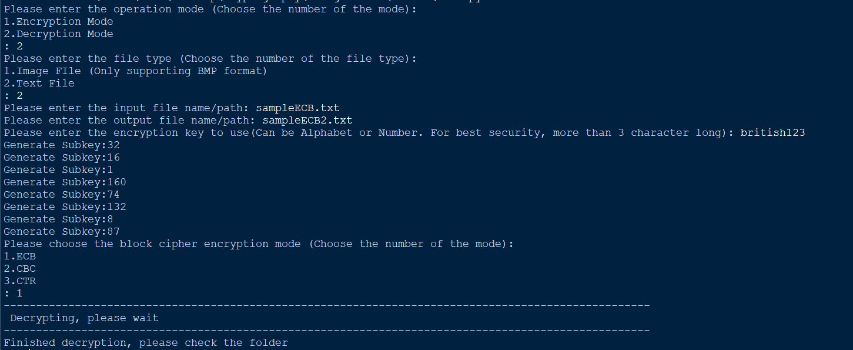

We get an output that is different from both the original sample text and the encrypted text.

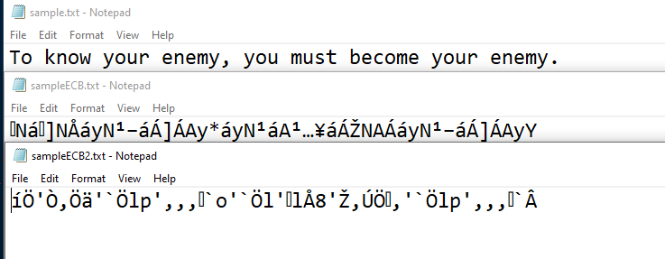

Now for the same process but for the images. For the first image, I used ‘halifax992’ as the key and ‘alberta9923’ for the second image, both image original key being ‘canada2020’.

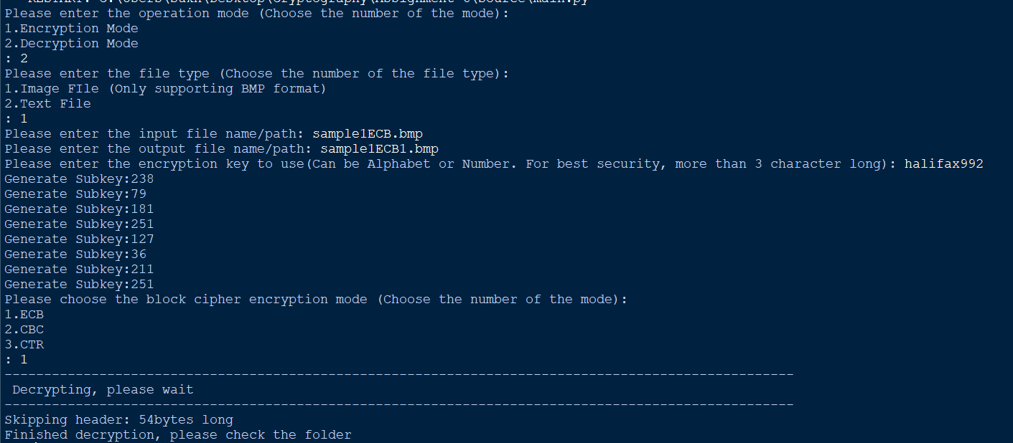

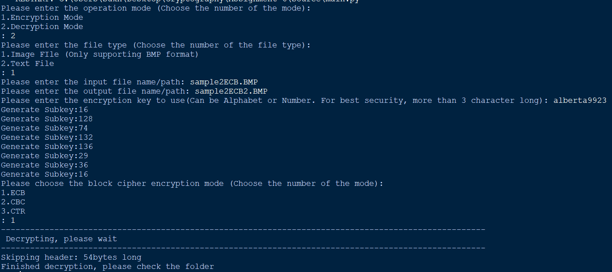

The following two images were the output after trying to encrypt.

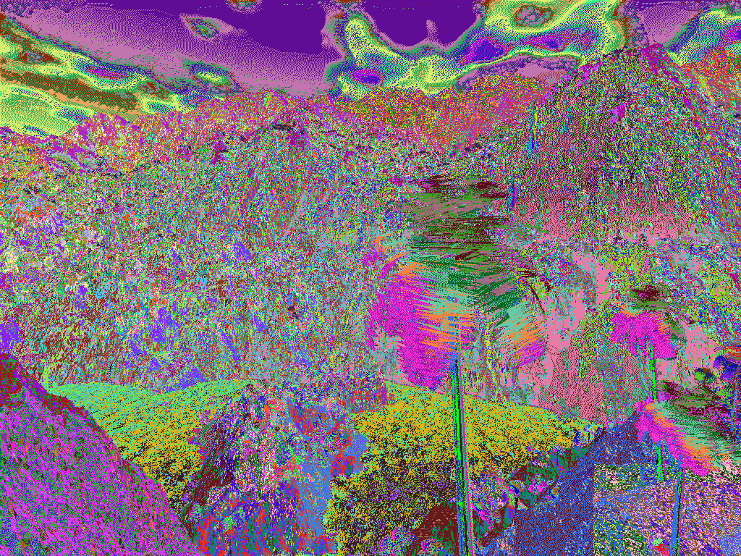 

Thus, showing that without the correct key, you cannot decrypt the image.

## Test 4

Here I’ll be repeating what I did for Test #1 but using CBC mode, starting off with the text file. I’ll be using the same key, ‘canada2020’.

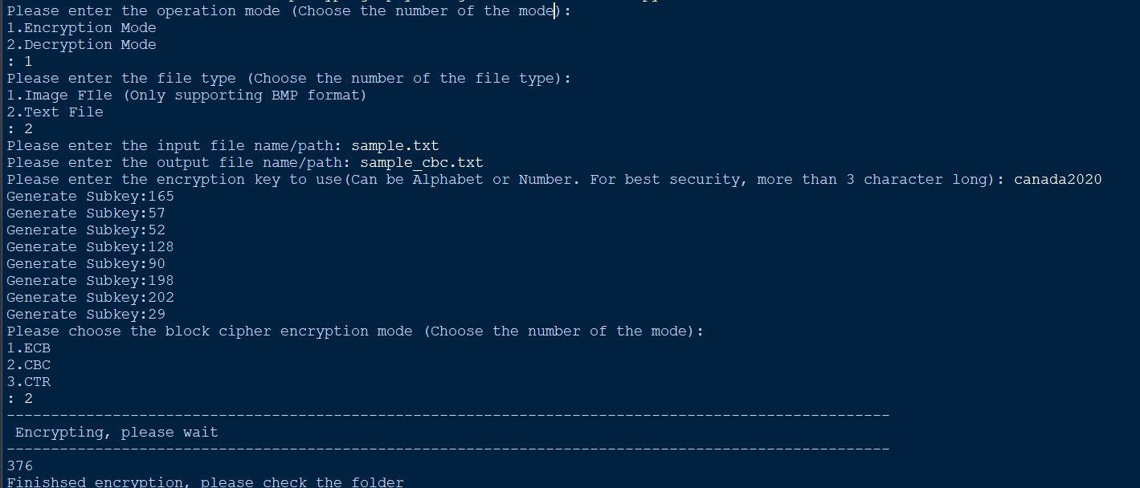

The following is the output of the text file which should be encrypted.

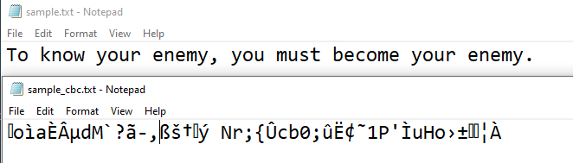

Which we can see is encrypted successfully using CBC. Now we’ll do the same process but for the two images.

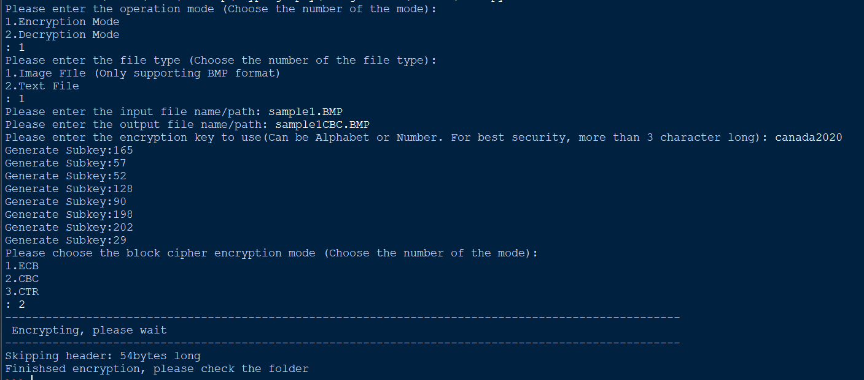

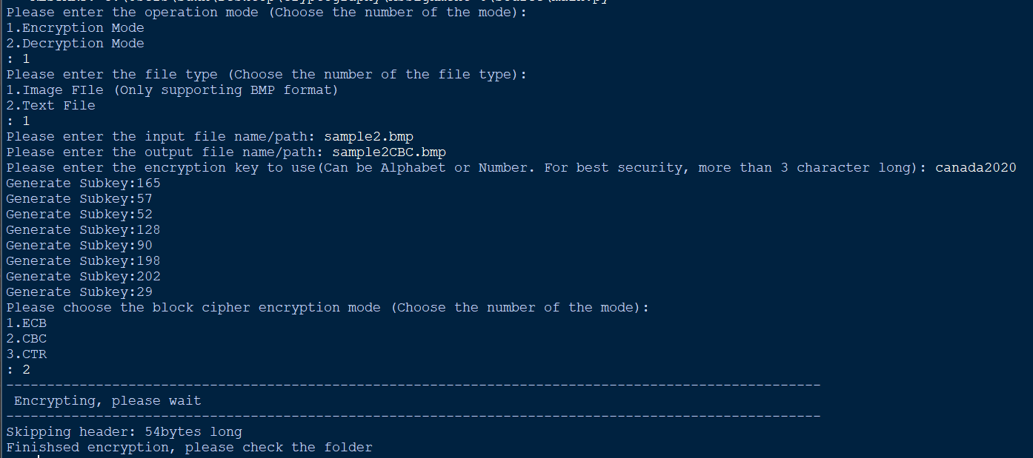

We can see that both images have been successfully encrypted below.

 

## Test 5

I’ll be decrypting the files from Test #4, starting off with the text file.

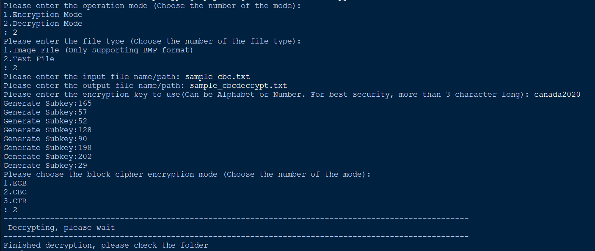

The decrypted image is as follows, showing that the text has been successfully decrypted to the original text from sample.txt.

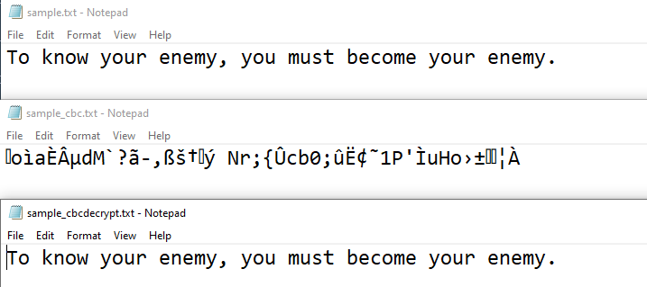

I’ll be doing this again for both the images now.

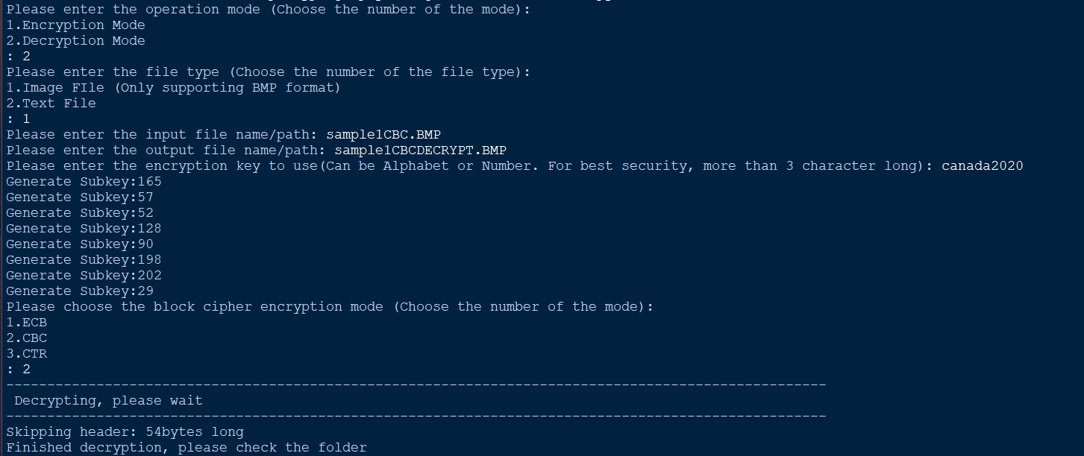

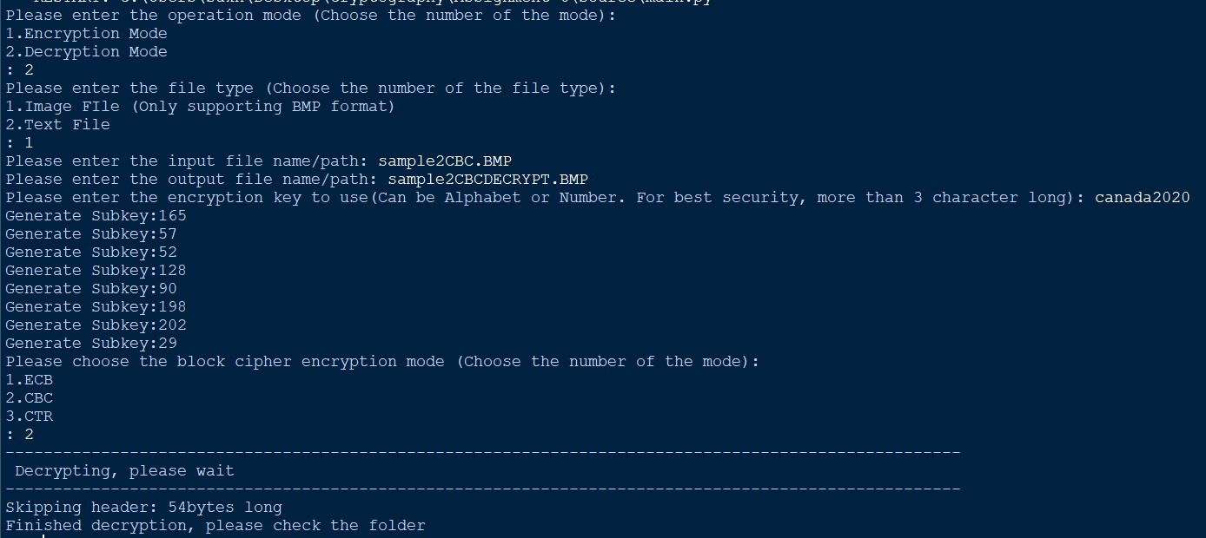

The following are the decrypted images, showing that the images were successfully decrypted.

 

## Test 6

Here I’ll show whether using a different key would be able to decrypt the encrypted files, starting off with the text.

Here I’ll be using a key of ‘jinnathom9’.

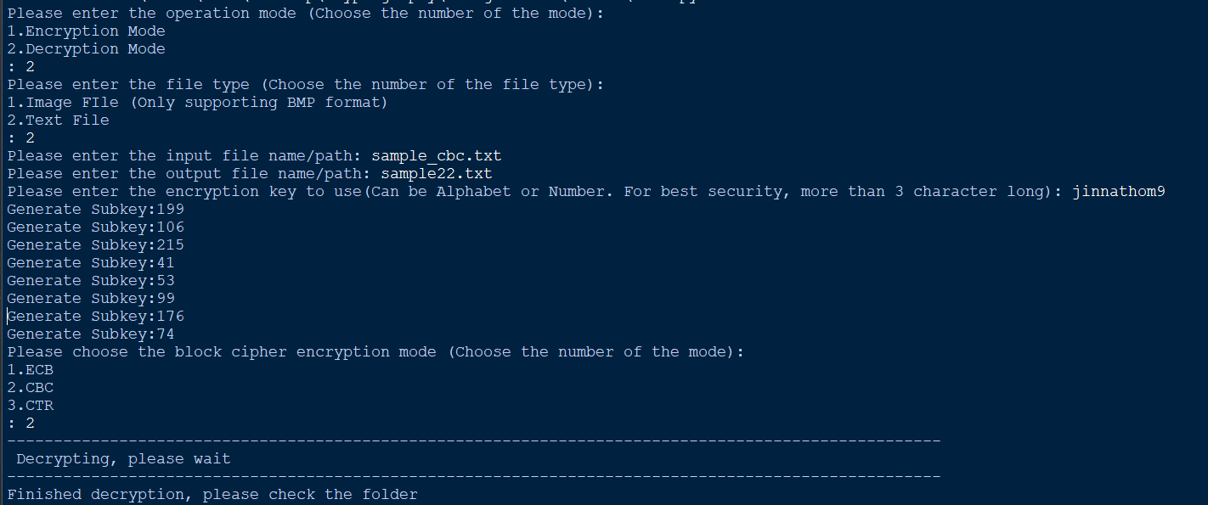

Below we can see that the text was not decrypted.

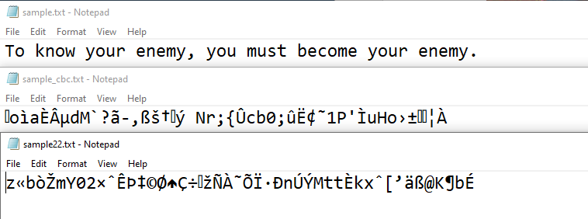

Next I’ll be doing it for both images with the key “onthehill92” and “britishcolumbia”.

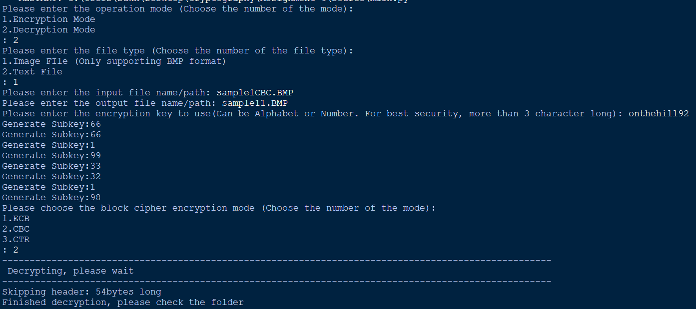

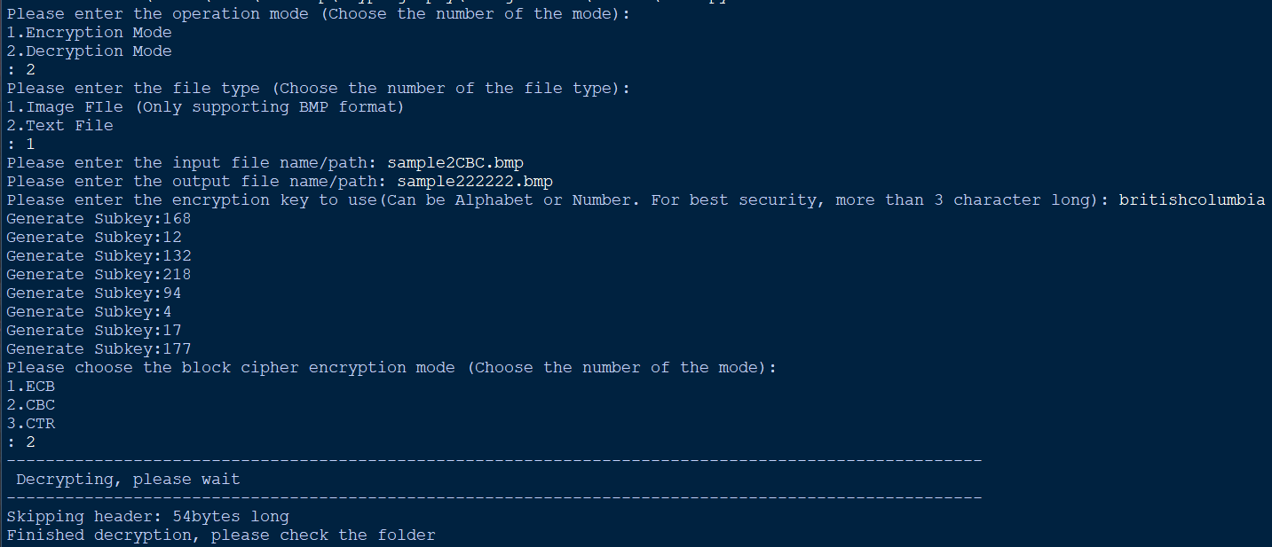

The following shows that the encrypted images were not able to get decrypted successfully.

 

## Test 7

Here I’ll be encrypting using CTR. I’ll be using the same key “canada2020” and a counter value of 27.

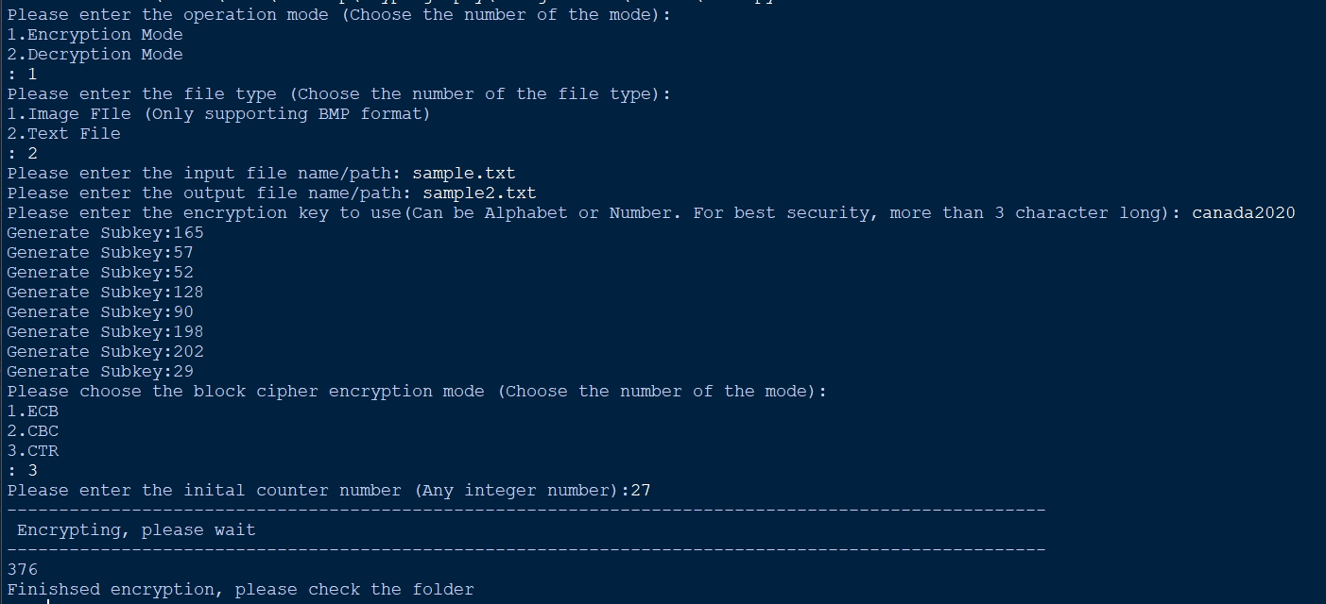

Below we can see the text was successfully encrypted.

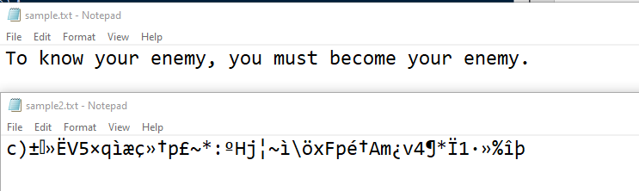

Now the same procedure but for the images.

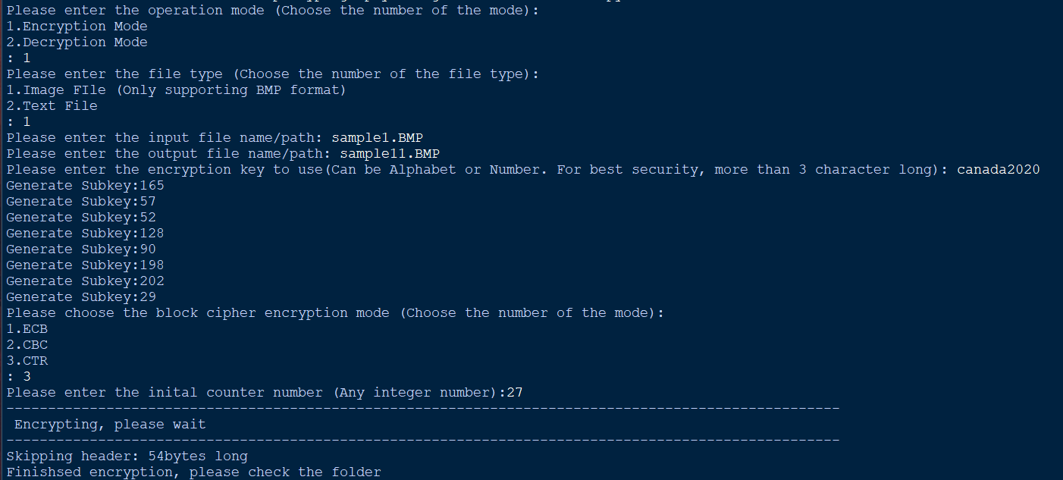

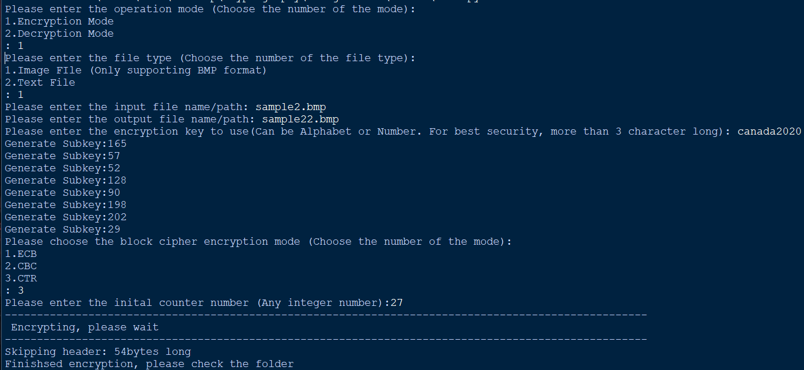

We can see that both images were encrypted successfully below.

 

## Test 8

Here we’ll decrypt the files that we encrypted in Test #7 using the key ‘canada2020’ and counter value of 27.

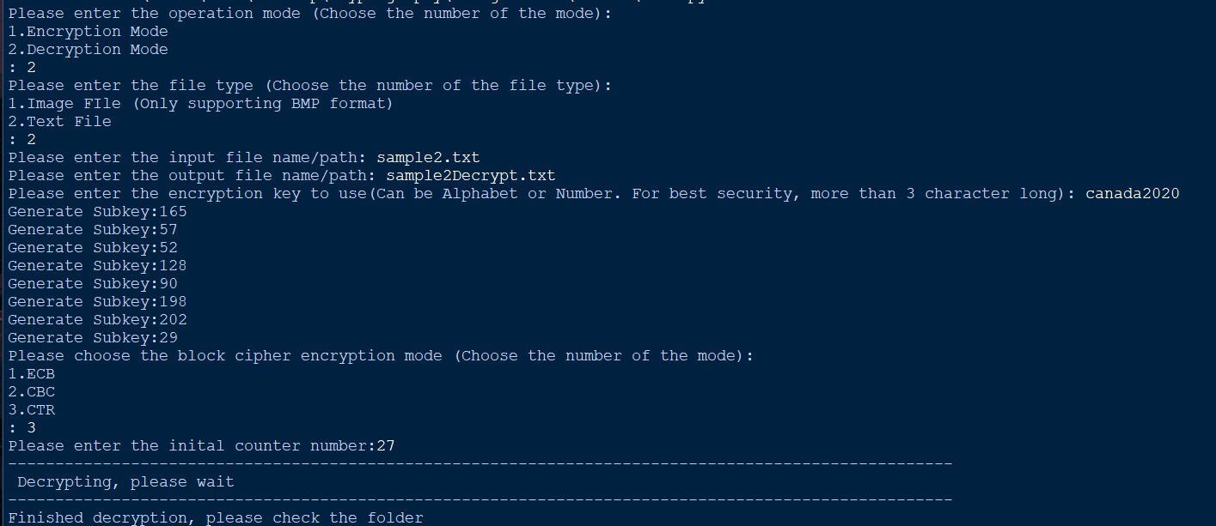

We can see that the text was successfully decrypted

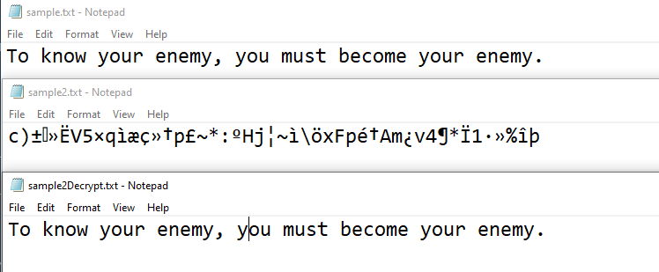

I’ll repeat the process for the images.

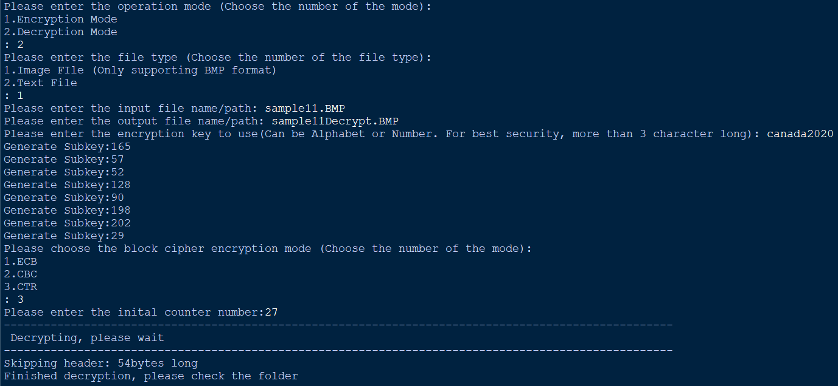

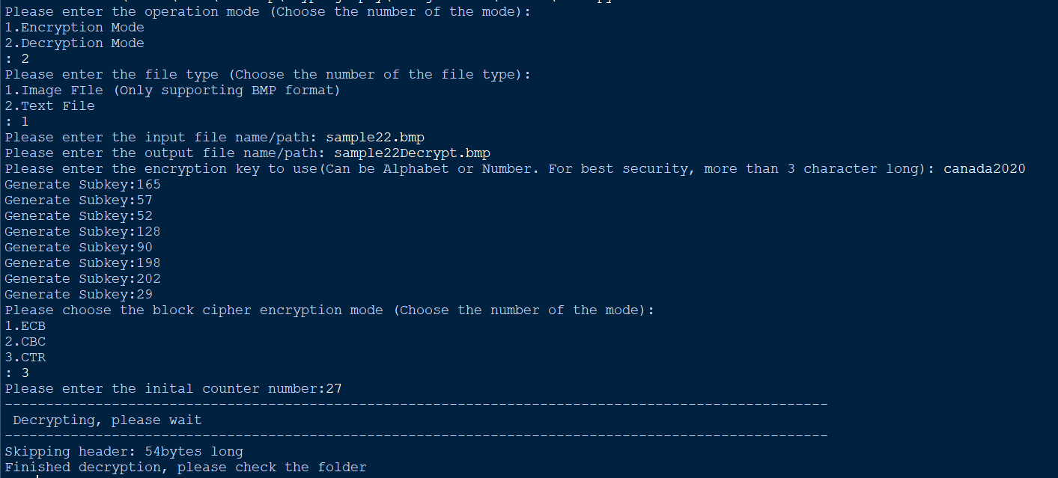

We can see below that both images were successfully decrypted.

 

## Test 9

Here I’ll try to decrypt the encrypted files using a key that is different from the one used to encrypt it initially. I’ll do two tests, one with the same key but different counter value and another with different key but same counter value.

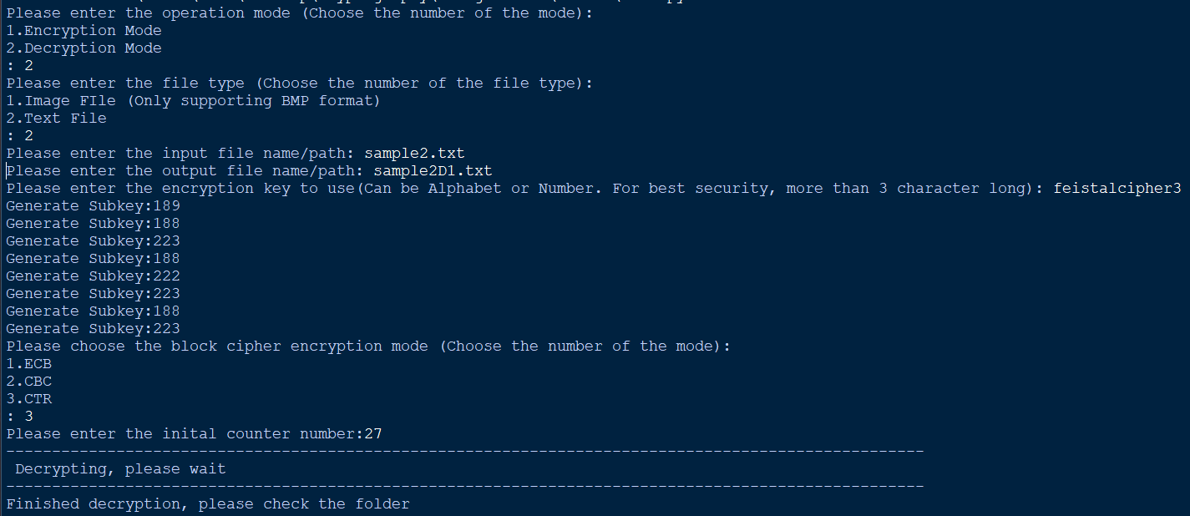

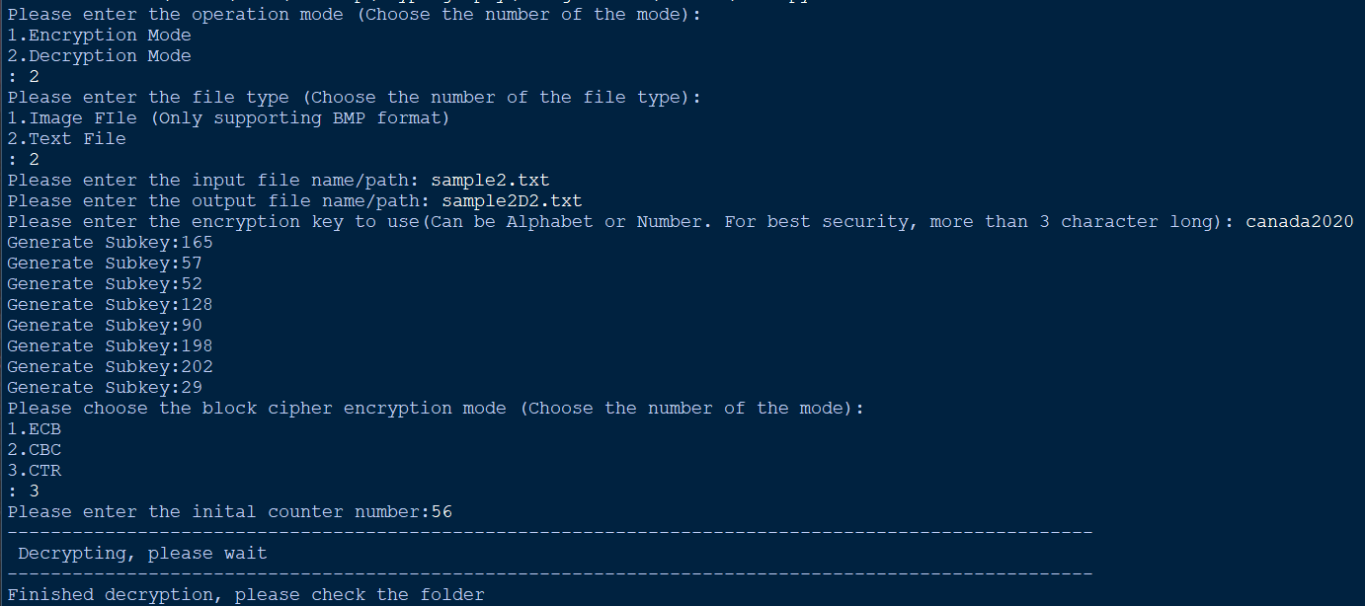

Below is the result from using the key ‘feistalcipher’ and the same counter value as the one when encrypting, 27.

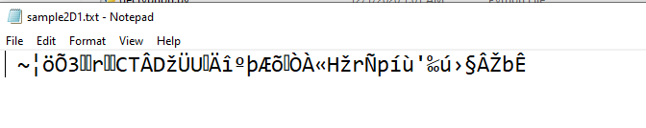

Below is the result from using the same key ‘canada2020’ but a counter value of 56.



We can see in both cases, the decryption failed.

Now I’ll do the same process but for the images. For the first image I’ll use the same key but a different counter value. For the second image, I’ll do the opposite with a different key but the same counter value.

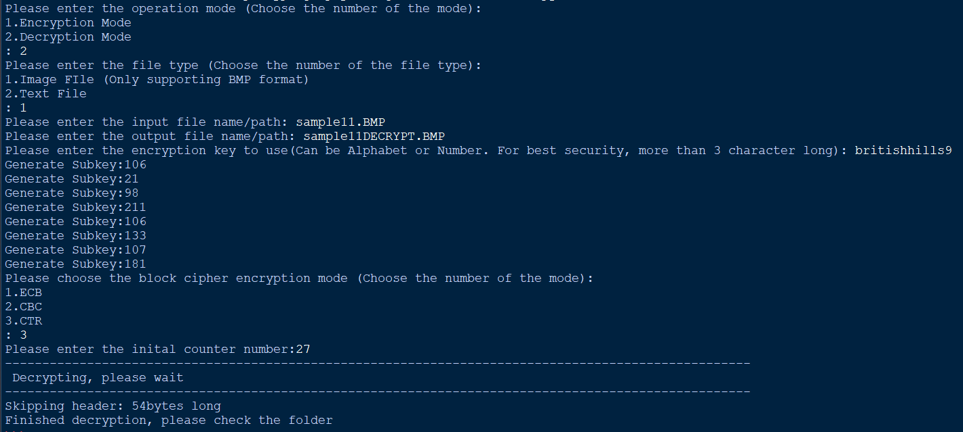

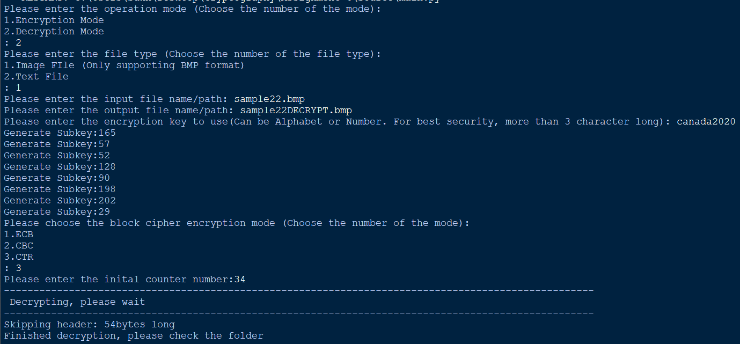

Below I used a different key, “britishhills9” but the same counter value as when encrypted the image originally “27”.



Here I used the same key, “canada2020” but a different counter value, “34”



We can see in both cases; the image was not successfully decrypted.